**EE 5111 CA3b Assignment for Control design**

**A0260045R MiaoChenxin**

1. PID controller for system

(1) State space model:

Known that the transfer function , the state model can be written as:

The error state-space model is:

= +

(2)

With error model, define the following cost function:

Designed that the Q = diag(100,100,100) and R = 1, K = -lqr( A, B, Q, R). the solution is

K = 10.0000 21.0564 2.6968

Ki = 10, Kp = 21.0654, Kd = 2.6968

The diagram and step response can be shown below:

Step response:

Control Signal:

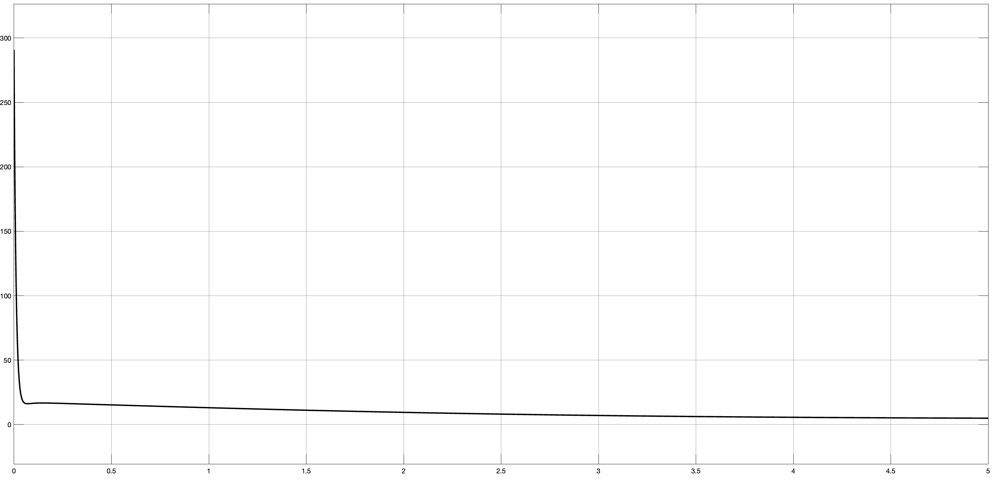

(3) Effect of Q and R weight

Q = diag(1000,1000,1000) and R = 1:

Ki, Kp,Kd = 31.6228 55.4991 16.6653

Step response:

Control signal:

门上的瓷砖

Q = diag(10,10,10) and R = 1:

Ki, Kp,Kd = 3.1623 9.0222 0.5547

Step response:

图形用户界面

Control signal:

Q = diag(100,100,100) and R = 0.01

Ki, Kp,Kd = 100.0000 170.9820 79.7233

Step response:

图形用户界面

Control signal:

图表

Q = diag(100,100,100) and R = 10

Ki, Kp,Kd = 3.1623 9.0222 0.5547

Step response:

Control signal:

瓷砖地上

Analysis:

If we increase the number in Q, the setting time of the system will be shorter, and the input signal will be larger. If we increase the number in R, the setting time of the system will be longer, and the input signal will be smaller. The larger Q also leads to larger K parameter whereas the larger R leads to smaller K parameter.

2. PLC and ladder diagram

